**Analyzing connectivity matrices without forcing into group atlas:**

**A multivariate approach**

Ju-Chi Yu1, Micaela Chan1,2, Liang Han1,2, Phillip Agres1,2 & Hervé Abdi1

1. School of Behavior and Brain Sciences, the University of Texas at Dallas

2. Center for Vital Longevity, the University of Texas at Dallas

[Ju-Chi.Yu@utdallas.edu](mailto:Ju-Chi.Yu@utdallas.edu), [mchan@utdallas.edu](mailto:mchan@utdallas.edu), [Liang.Han@utdallas.edu](mailto:Liang.Han@utdallas.edu), [Phillip.Agres@utdallas.edu](mailto:Phillip.Agres@utdallas.edu), [herve@utdallas.edu](mailto:herve@utdallas.edu)

**Abstract**

DiSTATIS (Abdi, et al., 2012)—a three-way multidimensional scaling (MDS)—is used to analyze resting-state functional magnetic resonance imaging (rsfMRI) data and to visualize the dissimilarity between networks. These dissimilarities are obtained by analyzing multiple distance matrices that have matching rows and columns (i.e., distinct functional regions in rsfMRI analysis). These functional regions are referred to as parcels or networks, and are usually derived from a shared template onto which all data are mapped. However, using a shared template from a particular group could bias results against participants that vary greater from this template, and this issue is particularly problematic amongst participants with diverse brain structures and functions (e.g., elderly, lesion patients, children). For such participants, the optimal parcellation would be the one that maximizes the homogeneity of the signal within each parcel region and of each participant. Recent work in rsfMRI analysis has developed techniques to derive individual-specific parcellations and sub-networks. Thus, the goal of this project is to propose a multivariate approach that accommodates differing parcel numbers and organization across participants.

**Methods**

The proposed multivariate approach first extracts the upper-triangle of the connectivity matrix of each participant session (Fig. 1A) and vectorizes it to form the rows of a data table. Sessions from the same participant are stacked to form a block of columns. Each participant's block is placed adjacent to one another to form the final data table, where the rows are sessions and the columns are network edges (Fig. 1B). Next, hierarchical multiple factor analysis (Fig. 1C) (Abdi, et al., 2013; Le Dien & Pagès, 2003) is used to preprocess the data table by normalizing each participant’s column-block by its first singular value, then dividing the column block of each edge-type (i.e., between- or within-network) within each participant’s column block by its first singular value. Finally, a PCA is performed to visualize the edges, participants, and sessions.

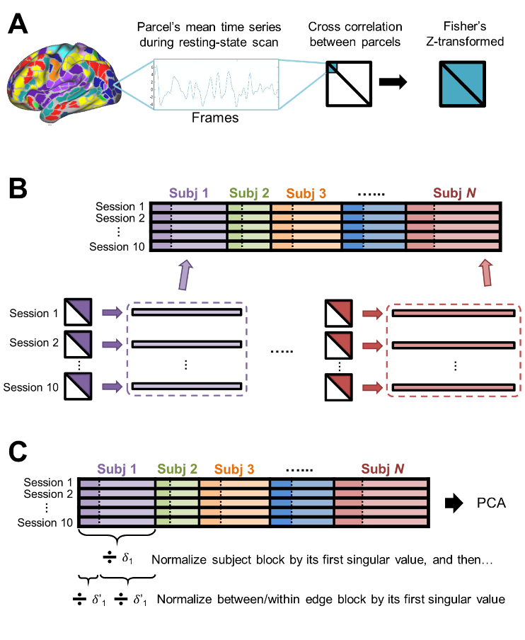

**Fig. 1**

To test this new technique, the Midnight Scan Club (MSC) dataset (Gordon, et al., 2017) was obtained from the OpenfMRI database (ds000224). This dataset was chosen because MSC has adequate rsfMRI data to produce individualized parcellation (i.e., 30 min × 10 sessions in each participant). Individual-specific functional parcellation was available for each participant (Gordon, et al., 2017), and the functional connectivity between two regions was computed by the Fisher’s *Z*-transformed correlation of their BOLD signals. Thus, the whole-brain functional connectivity of each session of each participant can be represented by a symmetric, region-by-region connectivity matrix. From the original MSC data, four sessions for each participant were selected for the analysis (sessions 1 – 4). For Sessions 2 and 4, the connectivity of three types of edges was manipulated to simulate commonly observed changes in functional brain networks: (1) decreases within the default mode network (DMN) and (2) increases between DMN and the frontoparietal network (FPN), and between the DMN and the dorsal attention network (DAN). Simulations of changes were restricted to specific networks to test whether the method could reveal where between-session changes are located.

**Results**

This new multivariate approach to analyzing the MSC data table showed that simulated sessions (2 & 4) are separated from non-simulated ones (1 & 3) on the first component (Fig. 2A). This separation is driven by the within DMN connectivity and several other between-network edges, including edges between DMN and FPN (Fig. 2B).

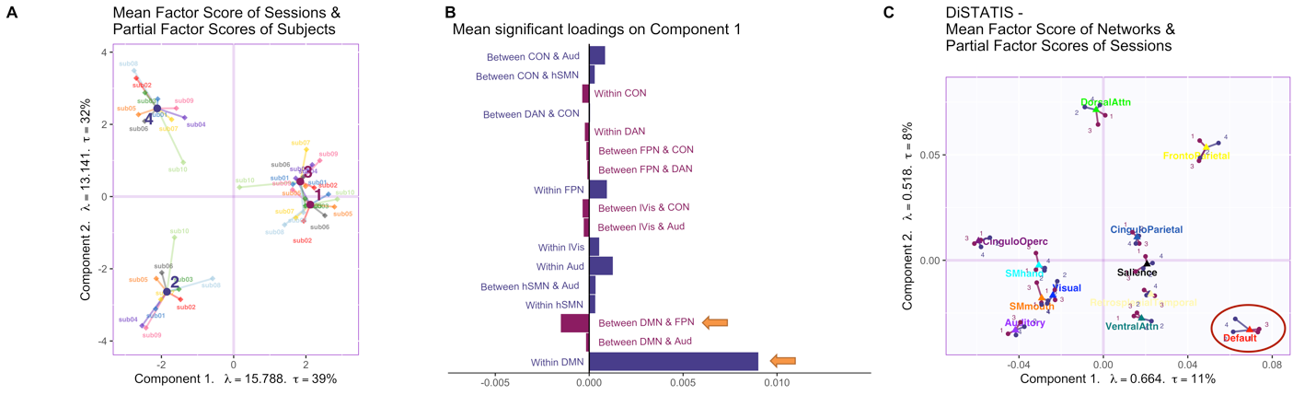

**Fig. 2**

A comparison analysis was conducted using DiSTATIS, where data were mapped to a shared template (Gordon, et al., 2016). Whereas DiSTATIS also revealed the session effect within DMN (Fig. 2C), between-network effects could not be detected.

In conclusion, this technique provides a multivariate approach to analyze functional connectivity with individual parcellation and is particularly useful when the connectivity is extracted from a participant group with diverse brain sizes, functional parcellation or organization schemes.

**References**

Abdi, H., Williams, L.J. and Valentin, D. (2013) 'Multiple factor analysis: principal component analysis for multitable and multiblock data sets.' *Wiley Interdisciplinary reviews: computational statistics*, **vol. 5**, no. 2, pp. 149-179.

Abdi, H., Williams, L.J., Valentin, D. and Bennani-Dosse, M. (2012) 'STATIS and DISTATIS: optimum multitable principal component analysis and three way metric multidimensional scaling.' *Wiley Interdisciplinary Reviews: Computational Statistics*, **vol. 4**, no. 2, pp. 124-167.

Gordon, E.M., Laumann, T.O., Adeyemo, B., Huckins, J.F., Kelley, W.M. and Petersen, S.E. (2016) 'Generation and Evaluation of a Cortical Area Parcellation from Resting-State Correlations.' *Cerebral Cortex*, **vol. 26**, no. 1, pp. 288-303.

Gordon, E.M., Laumann, T.O., Gilmore, A.W., Newbold, D.J., Greene, D.J., Berg, J.J., Ortega, M., Hoyt-Drazen, C., Gratton, C., Sun, H., Hampton, J.M., Coalson, R.S., Nguyen, A.L., McDermott, K.B., Shimony, J.S., Snyder, A.Z., Schlaggar, B.L., Petersen, S.E., Nelson, S.M. and Dosenbach, N.U.F. (2017) 'Precision Functional Mapping of Individual Human Brains.' *Neuron*, **vol. 95**, no. 4, pp. 791-807.e7.

Le Dien, S. and Pagès, J. (2003) 'Hierarchical Multiple Factor Analysis: application to the comparison of sensory profiles.' *Food Quality and Preference*, **vol. 14**, no. 5, pp. 397-403.